Name: Omar A. Shakir Al-Faiadh
ID: 201735167

BANA540: Vehicle sales

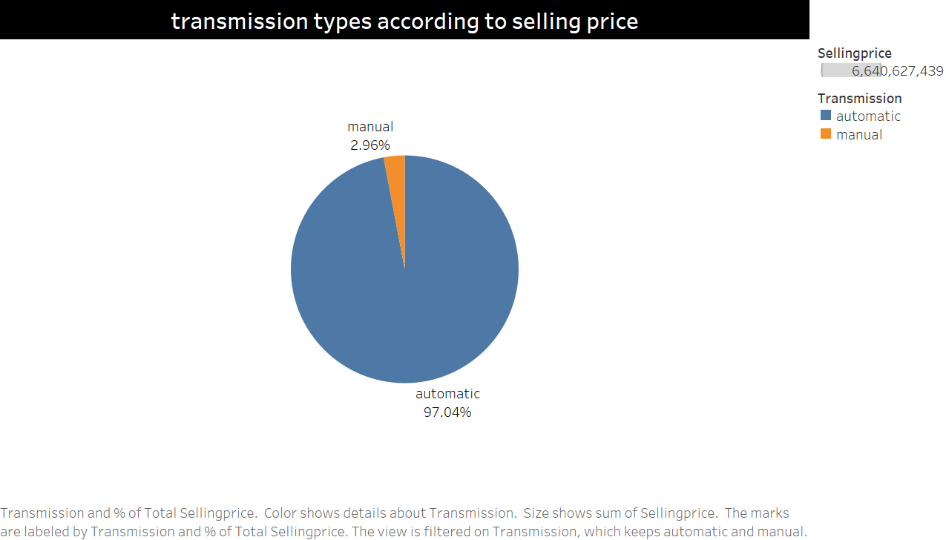
This pie chart shows the percentage of total selling price of manual and autmoatic transmission in vehicle sales.

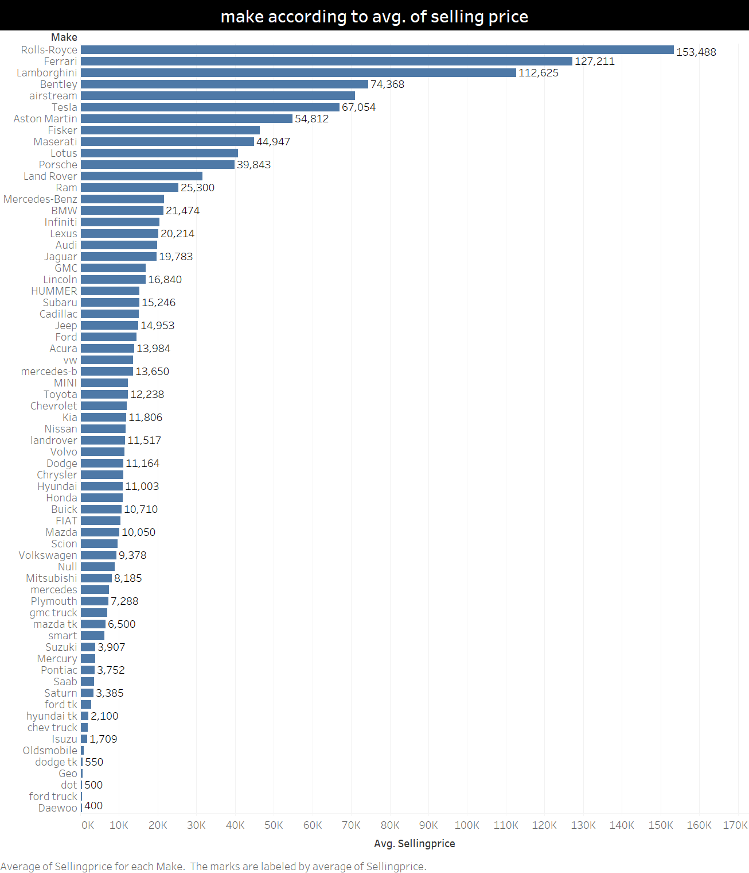
This bar chart shows the top of vehicle companies according to the average of selling price.
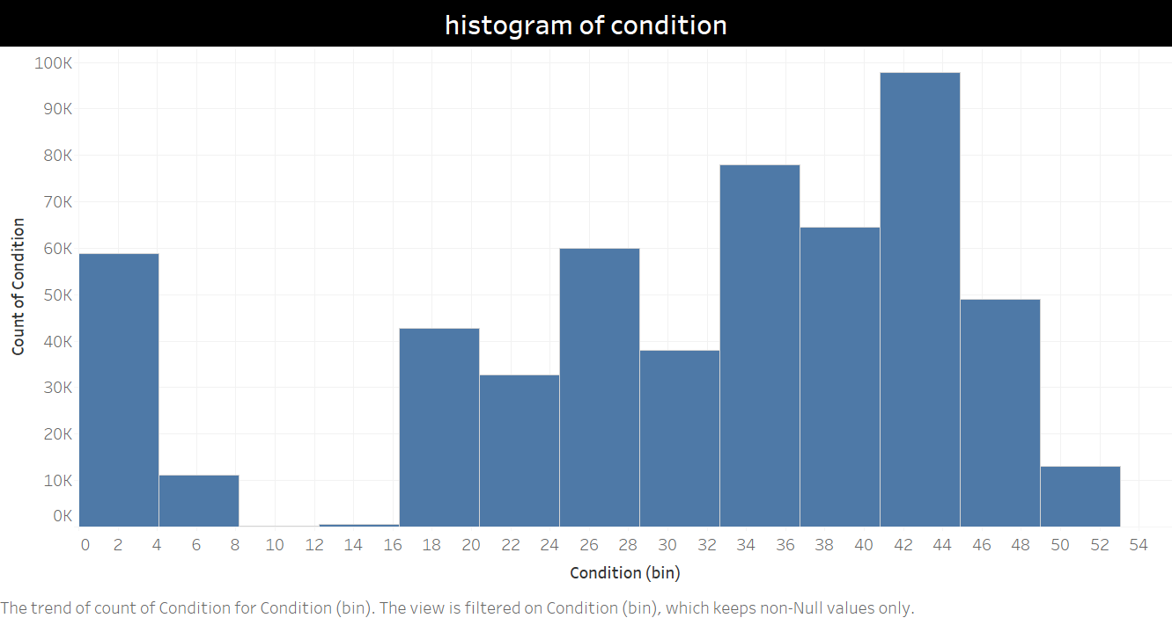

This histogram shows the normal distribution of vehicle condition.
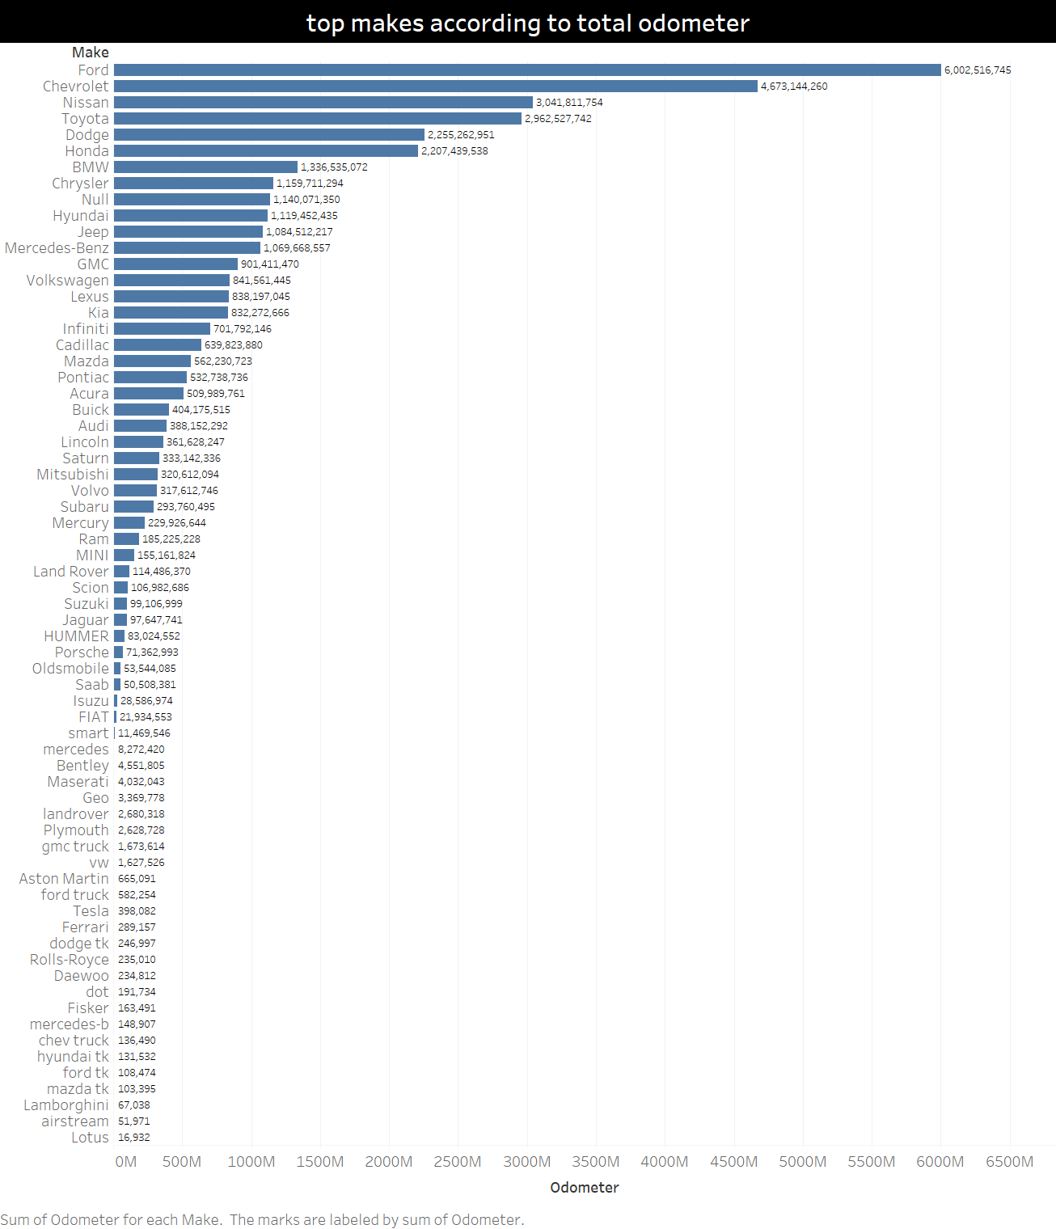
This bar chart shows the top vehicle companies of the total of odometer.

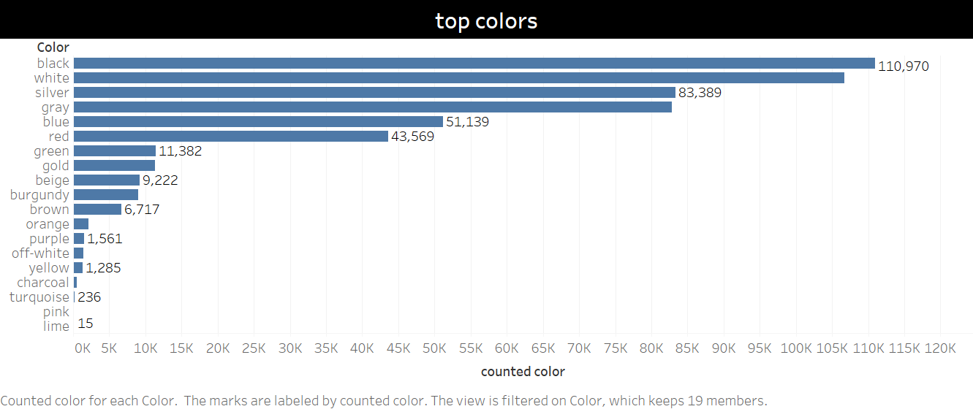
This bar chart shows which vehicle color is more common in vehicle sales.

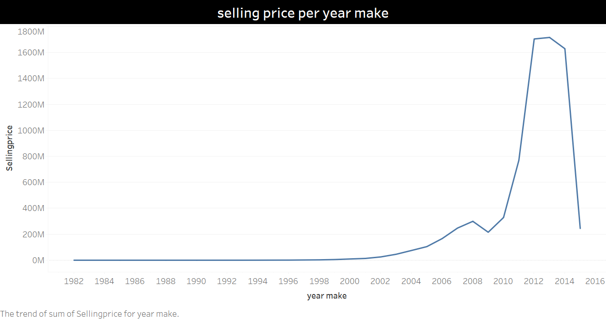
This line chart shows the selling price per year make in vehicle sales.

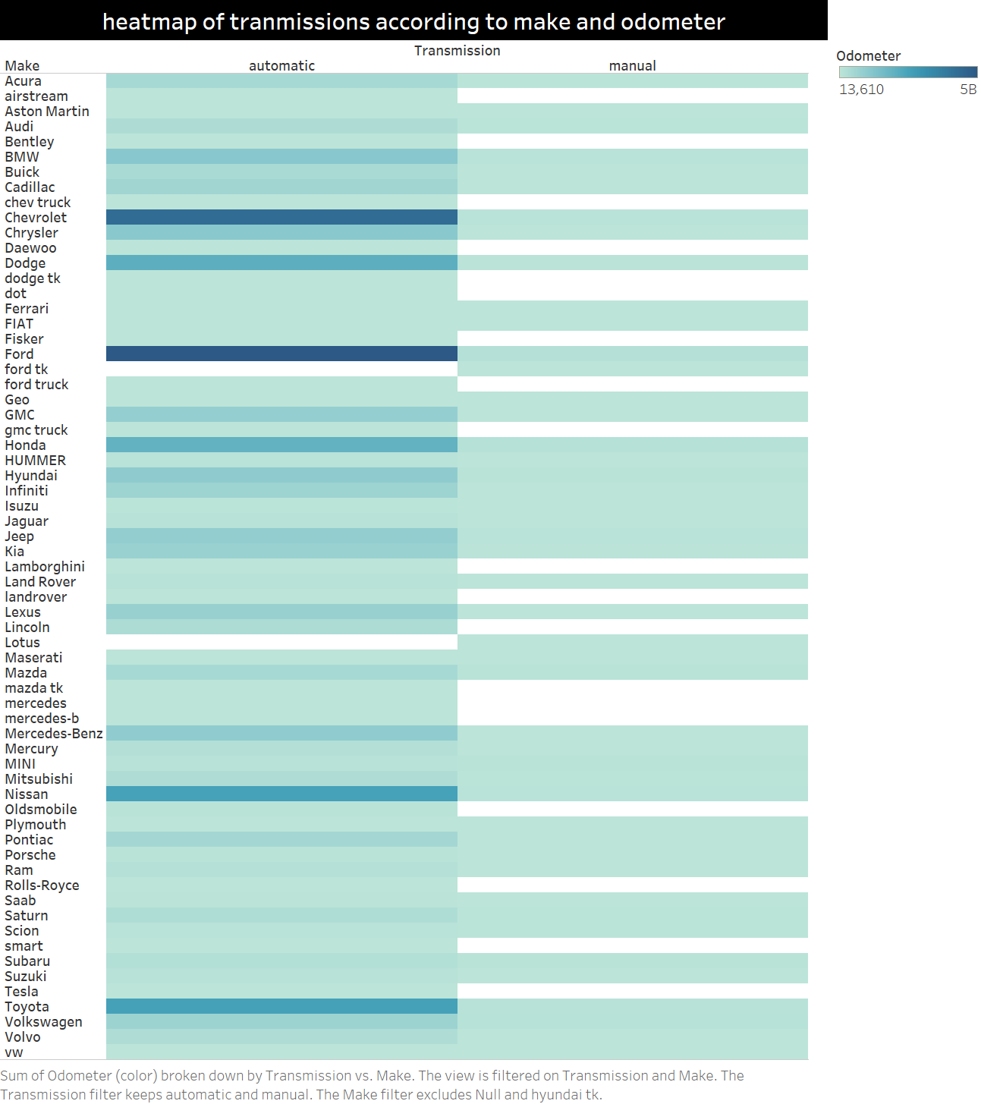
This heatmap shows the odometer (which is how dark/light the color is) of vehicle companies (represented as make) for both transmission types (manual and automatic).
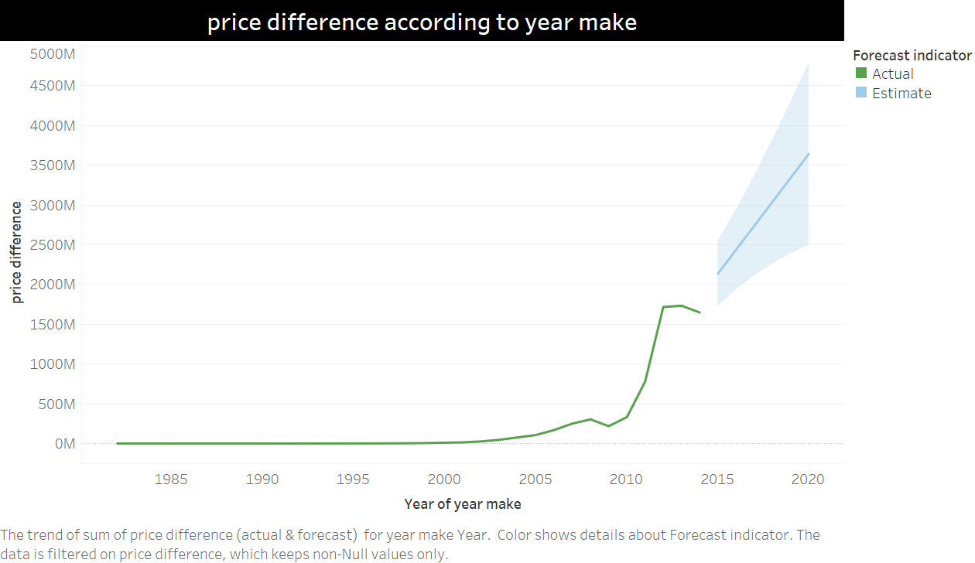
This line chart shows the price difference (calculated field that shows the difference between selling price and mmr). Moreover, it shows the forecast for the next few years of the price difference according to the year that vehicle will be made in. Note: this data is old. So 2015 represents the future for this data.
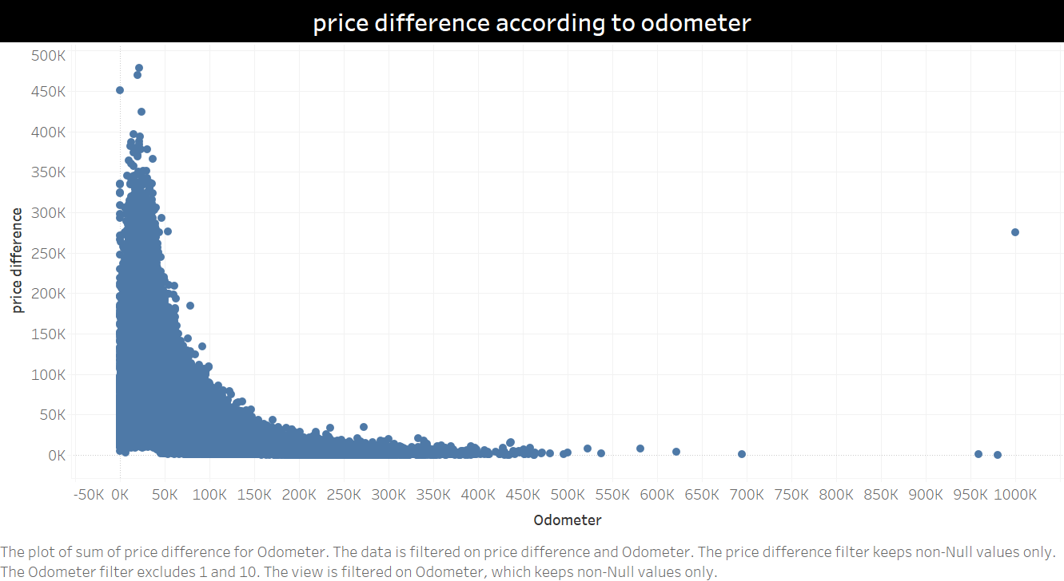
This scatter plot shows the change in price difference according to odometer 2 outliers were excluded.
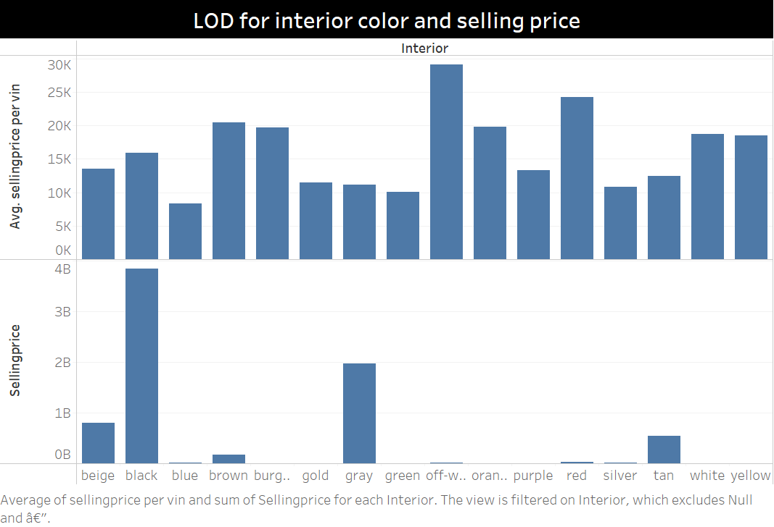
This LOD shows 2 column charts where the x-axis shows the interior colors. The y-axis for the first column chart is the average of selling price per vin (calculated field). While the y-axis of the second column chart shows the total selling price. LOD helps in comparing between the total selling price of each interior color with the average of selling price per vin for each interior color.
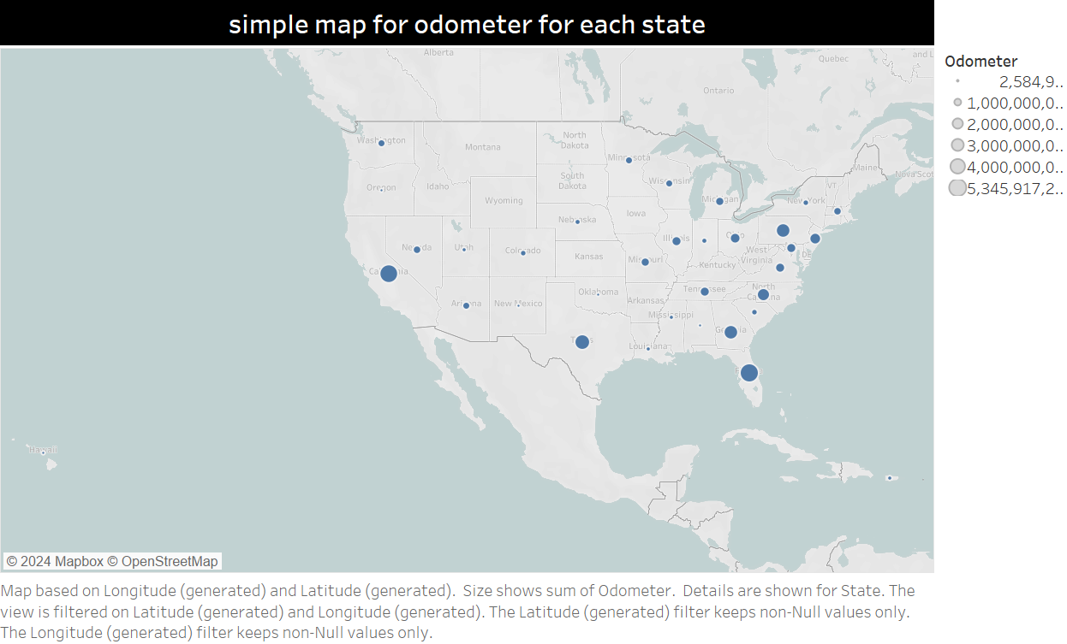
This simple map shows the odometer (represented by the size of the circle) for each state.
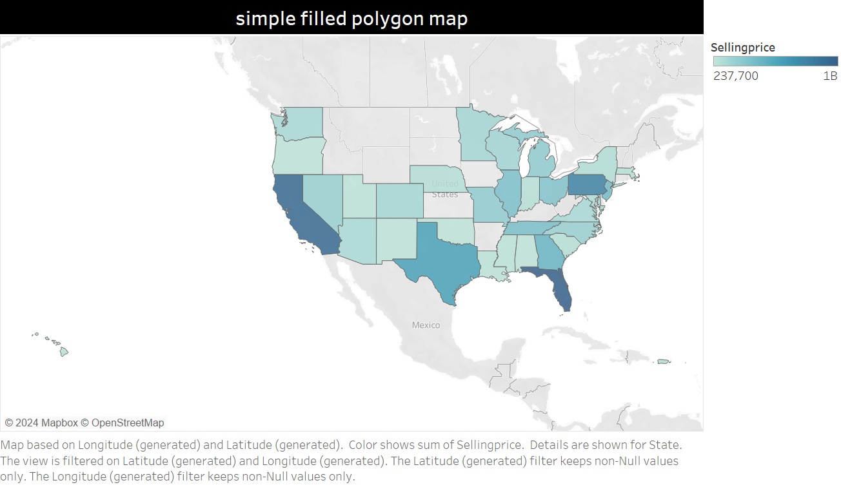
This simple filled polygon map shows the selling price in each state.
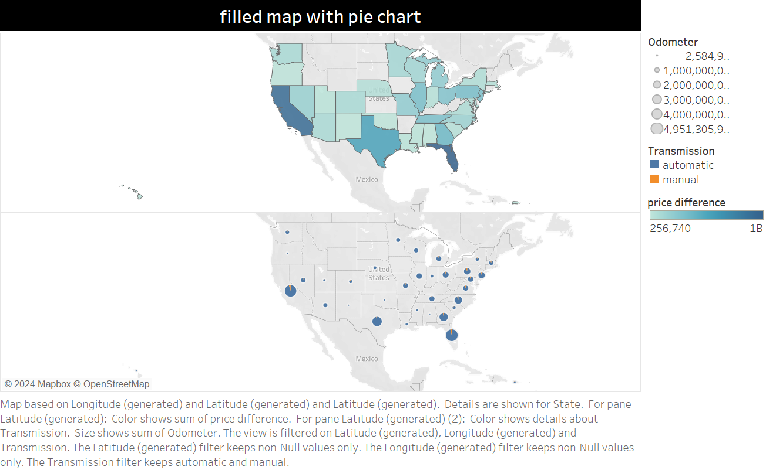
This filled map with pie charts shows the odometer (represented by size), transmission types (represented by blue and orange), and the price difference (represented by the above filled map) for each state.
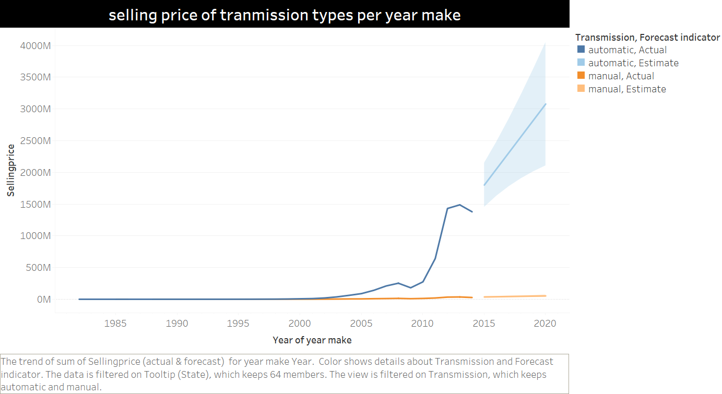
This line chart shows the change of selling price over the year of make for both transmission types, manual and automatic. Moreover, it shows the expected change of selling price for the vehicles that will be made in the next few years.
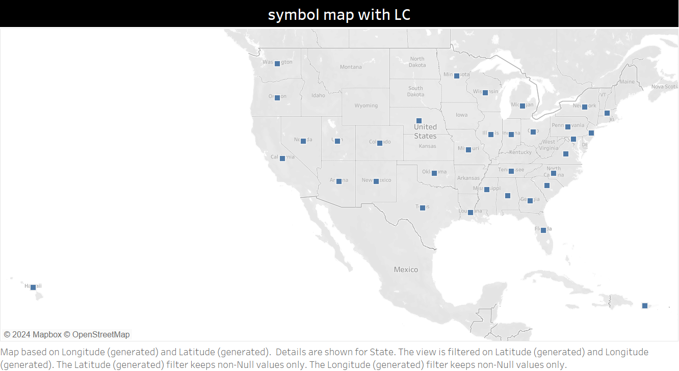
This symbol map shows the state provided with Line charts (added using tooltip). This part will be shown better in the presentation since hovering is needed to show the line charts that was added using tooltip (the line chart that was used in the tooltip is the one that was shown directly before this map).
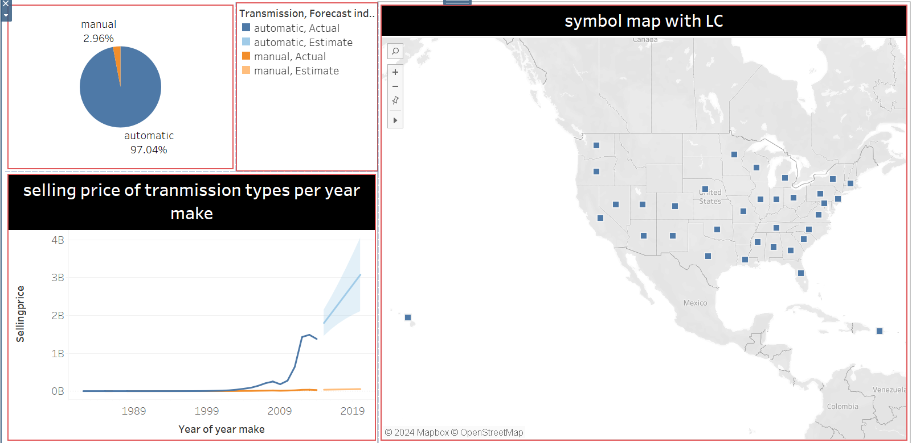
This dashboard gathers 3 different visualizations (that was discussed before in this document). All 3 visualizations share the factor Transmission types. The dashboard helps in comparing and understanding the visualizations of transmission types by gathering them in one place.
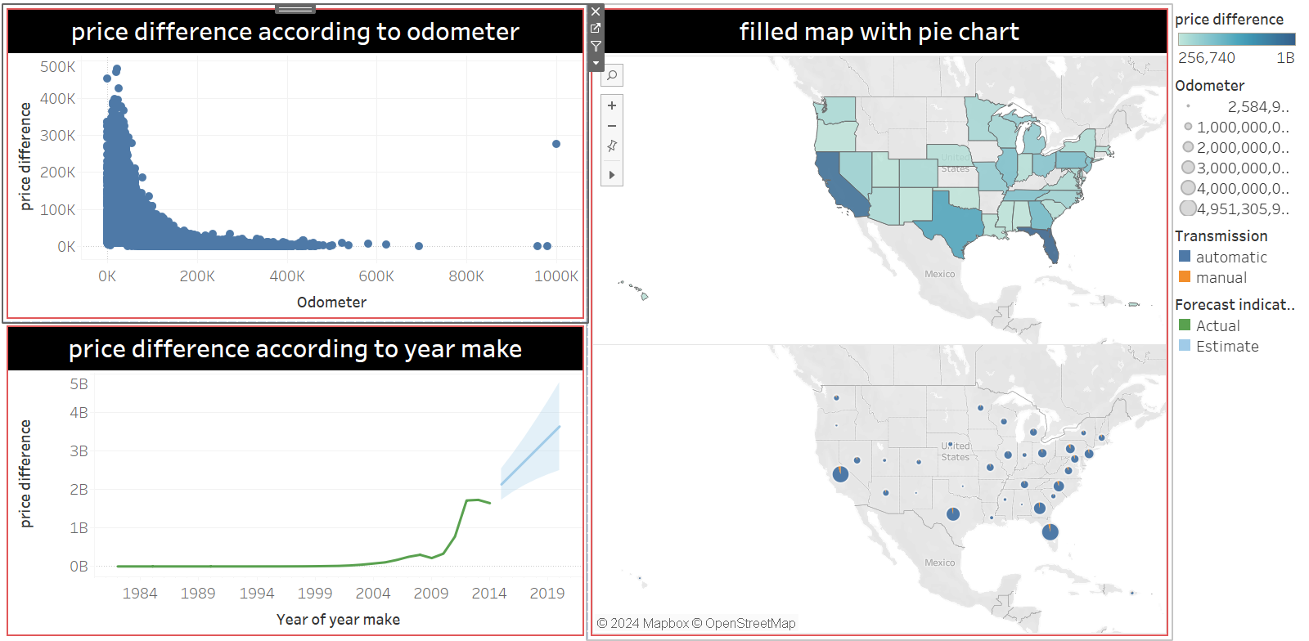
This dashboard gathers 3 different visualizations that share the factor of price difference.

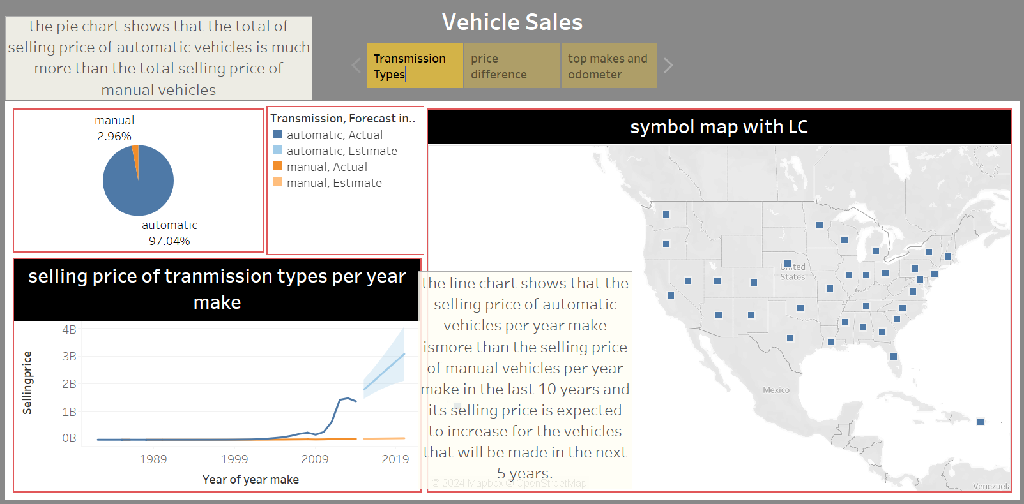
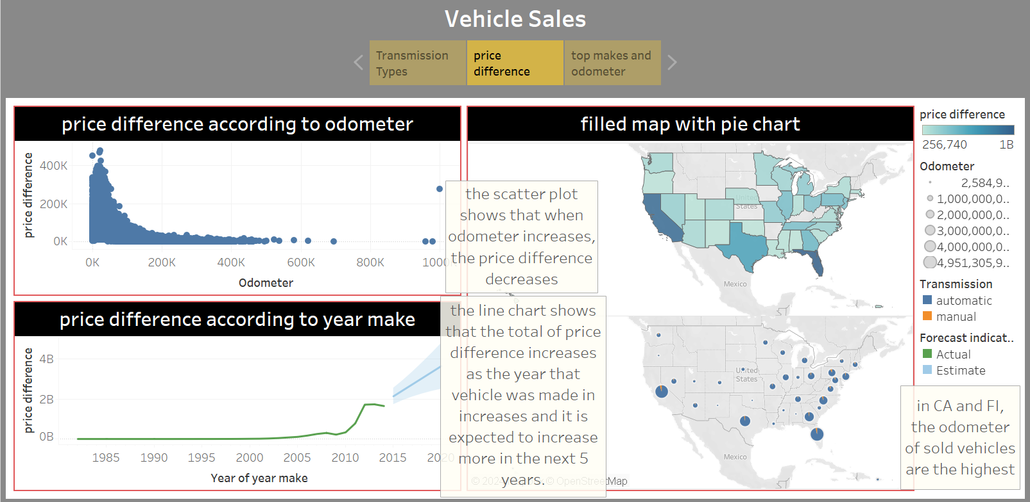
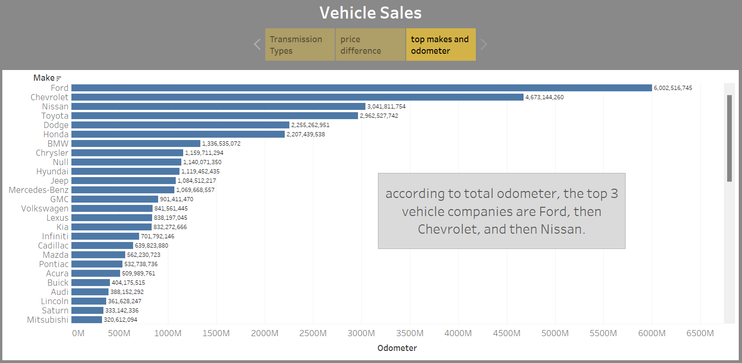
This story tell us about 3 different factors of vehicle sales, which are transmission types, price difference, and top makes according to odometer. The story shows different insights about each of the dashboards and the visualization that are shown above in the vehicle sales story.

